**Module 1: Critical Thinking**

Brandy Martinez

Colorado State University Global

CSC320: Programming I

Chris Whitfield

08/18/2024

**List Individual’s Name and Address Information**

The pseudocode is a set of instructions in no particular programming language. It is sort of like an outline to a program. Below I have created a general outline of a program that would print out a list including an individual’s name and address information.

// Obtain individual's information

firstName: string

lastName: string

streetAddress: string

city: string

zipCode: string

// Function to display

print firstName

print lastName

print streetAddress

print city

print zipCode

// Main program display

Enter first name:

Brandy

Enter last name:

Martinez

Enter street address:

123 Maple St

Enter city:

Victorville

Enter zip code:

12345

End

The following code is the code source which is in the Java programming language in which it is more detailed describing classes and the programs main function which would be to print out the information in a list format.

**package** com.sample;

**import** java.util.Scanner;

**public** **class** Main {

// Function to display the individual's information

**public** **static** **void** DisplayInformation(String firstName, String lastName, String streetAddress, String city, String zipCode) {

System.***out***.println(firstName);

System.***out***.println(lastName);

System.***out***.println(streetAddress);

System.***out***.println(city);

System.***out***.println(zipCode);

}

**public** **static** **void** main(String[] args) {

Scanner scanner = **new** Scanner(System.***in***);

// Main program to input and display information

System.***out***.print("Enter first name: ");

String firstName = scanner.nextLine();

System.***out***.print("Enter last name: ");

String lastName = scanner.nextLine();

System.***out***.print("Enter street address: ");

String streetAddress = scanner.nextLine();

System.***out***.print("Enter city: ");

String city = scanner.nextLine();

System.***out***.print("Enter zip code: ");

String zipCode = scanner.nextLine();

// Display the entered information

*DisplayInformation*(firstName, lastName, streetAddress, city, zipCode);

// End of program

System.***out***.println("End");

scanner.close();

}

}

Next, we have the source code being executed and at the bottom the results of the program can be viewed. It is important to note that this type of program requires input from a user which is shown in the green text. This allows the program to properly format the information for its intended purpose.

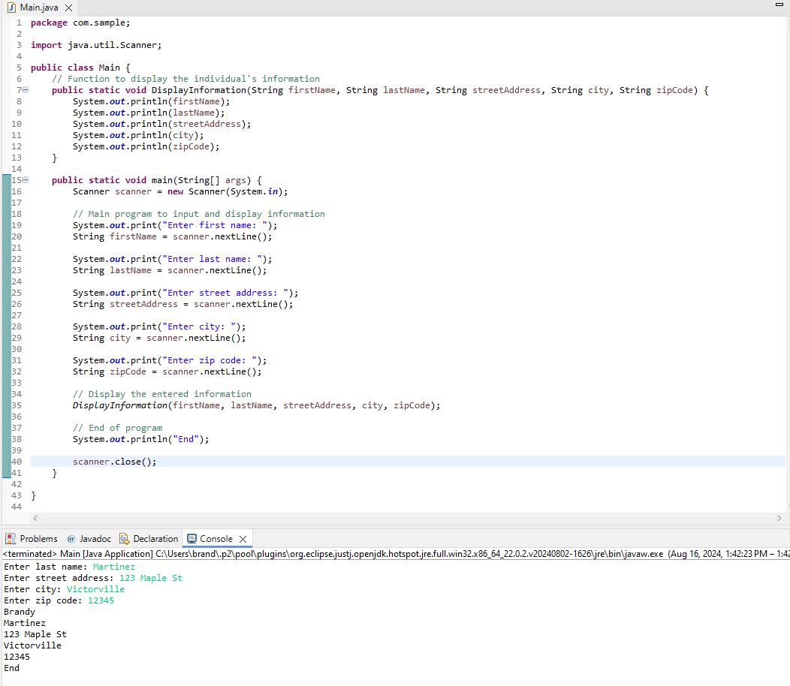

**References**

GeeksforGeeks. (2024c, June 30). *Git tutorial*. https://www.geeksforgeeks.org/git-tutorial/